
AUGUST 2017

CREEK TIMES
604Village Drive, Marshall, MN. 56258 (507) 929-1234
Our Mission: To establish a stable foundation for our adults with dementia through services, community, choice and individuality.  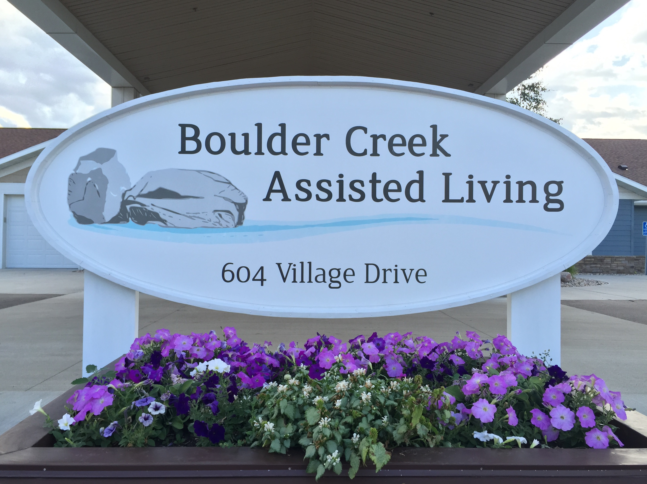  tammy@boulder-creek.org  Entertainment  Aug. 3 @ 1:15-Danna and LuAnn  Aug. 4 @ 3:45-Sing with Beth  Aug. 30 @ 3:45-Craig BlackStag  Church Schedule  Aug. 9 @ 10:45 Catholic Mass (S)  Aug. 15 @ 2:00 Hymns w/Johnston  Aug. 17 @ 2:00 Church w/Pst. Julie  Every Thursday @ 10:00 is Rosary in the South Chapel | 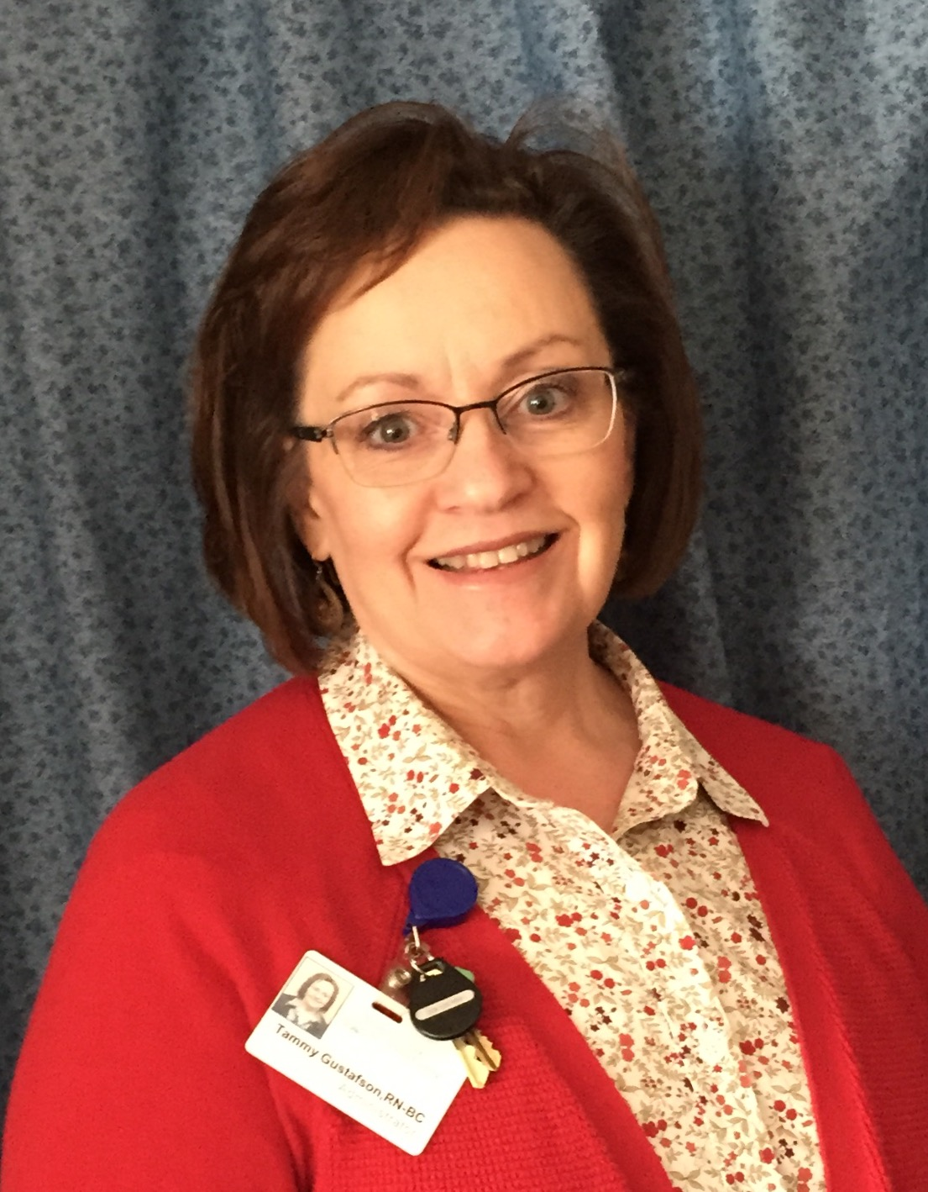  Why do care levels change? Most often a care level changes because the level of care needs of the tenant change. Each of the care levels is allowing for an amount of time per day, from staff time with the individual of 30 minutes up to several hours per day. Periodically I will ask the case managers to do an audit of each client’s cares at Boulder Creek and the amount of staff time being used for the individual’s needs. The purpose is twofold; to make sure we have adequate staffing and that we are accurate on the time being allowed and the care being provided to your loved one. When we begin to see a pattern of changes, we review the services more closely for accuracy before we make changes to an individual’s care level rate. We will notify you when there is a level change/rate change. If there is a change, we will need you to sign a new service agreement with this care level update, within two weeks of being notified.  New job opening: Do you know someone who is maybe retired, that would like to get back into the work force, but work only a few hours and have a flexible schedule? Boulder Creek is looking for someone willing to do some sorting, organizing, rearranging of supplies. Possibly some mending, hemming, sewing on buttons or labeling clothing. These are just some ideas of things that can be done, but are not ‘time sensitive’ leaving you flexibility. This position is no more than part time. You can have scheduled hours or let us know when you are available. No holidays, no weekends required. Starting pay is $9.50/hour. Talk to me if you are interested.  Vacations: Stella is on vacation and will return on August 3rd. I will be on vacation August 10 -20th and return to work on August 21st. If you have questions while I am away, please talk with Stella or Melissa they will know how to reach me if needed.  Enjoy the rest of your summer!  Tammy

  August 2017  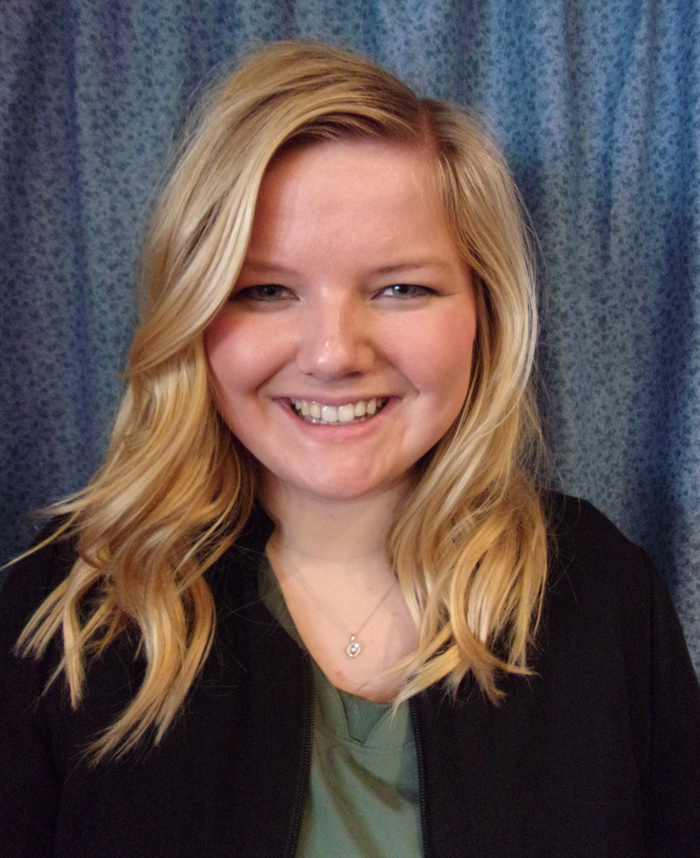  Circulatory System and Diabetes  The circulatory system is responsible for delivering blood throughout the body. One of its functions is to regulate blood glucose levels. The hormone glucagon is carried in the blood. It signals the liver to release glucose into the blood and the presence of insulin in the blood instructs the cells to take in glucose from the blood. If blood glucose levels become too high for extended periods of time, the blood vessels become damaged. When blood vessels become damaged, this results in common diabetic complications. Neuropathy, also known as nerve damage, results from damage of the blood vessels. If the blood vessels are not able to feed the nerves, they die. When blood vessels feeding organs are damaged, this can permanently damage the organ.  If you have any questions, feel free to contact me at (507) 929-1234 #3. Thank you!  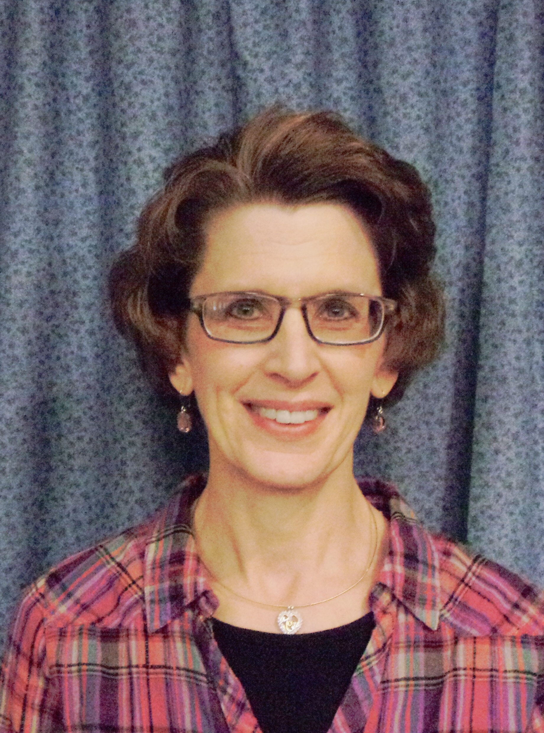Updates from Jane:  August is already here! Where did the Summer go? Some fun activities coming in August are: Singing with Dana & LuAnn, Sing-A-Long with Beth, and visits from the Samuel Lutheran Kids and the YMCA Kids. On Thursday, August 10th we have the Shades of the Past Car Club coming at 6:00pm and they are serving Root Beer Floats & giving the tenants rides in their “old time” cars! Feel free to come and have a Root Beer Float with your family or friend! The next day, August 11th we have our fun YMCA Outing and some tenants ride the taxi to the YMCA for exercise,  snack and an activity. This month we will also |   Welcome to our team!    Tammy HHA Justina HHA    Marline HHA  be having Baby Play Date on Monday, August 14th, feel free to come and visit as the tenants enjoy the babies & their siblings with songs and games. On Wednesday, August 16th we have Uncle Ron’s Band at 4:00pm with music, singing and, of course, dancing! Once again, feel free to come and enjoy this entertainment with your family or friend! We have a new entertainer this month on Wednesday, August 30th at 4:00pm, Music with Craig Blackstad---Music memories of Elvis Presley, Bobbie Vinton, Paul Anka, etc. Come and enjoy! We have some fundraising activities this month on Tuesday, August 8th at 5:00pm, we have a Canvas Painting Fundraiser, check our Facebook page for information to sign up and paint. Also, we are having another Garage Sale Fundraiser on Thursday, August 31st, in the Boulder Creek Parking Lot from 9am-6pm. We are accepting donations again, so feel free to drop them to Boulder Creek! Enjoy August!
August 2017    Walk To End Alzheimer’s Fund Raisers  In the month of August we will be having two events to help raise money for the September “Walk To End Alzheimer’s”.  The WTEA is on September 23rd in St. Cloud at Lake George Municipal Park. If you would like to register you can call (320)-257-0696 or log on to alz.org/walk  Our first fund raiser this month will be Canvas Painting taking place here at Boulder Creek in the Community Room on the 8th of August at 5:30pm. A percent of the cost of the class will be donated to WTEA.  Our second fundraiser will be our fall garage sale on August 31st from 9am to 6pm. If you or anyone you know would like to donate items for the garage sale please bring them to Boulder Creek by August 28th. Thank you so much for everyone’s donations for our spring garage sale! With your donations we were able to raise a little over $500!  On Fridays we have “Casual Friday”. The staff pays $2.00 if they want to wear jeans. So far we have raised $35. | Employee of the Month    August Employee of the Month for Boulder Creek: Crista Schultze, HHA  Crista joined Boulder Creek in November 2016. She was nominated by her coworkers and supervisors for her great attitude, willingness to go the extra mile for both coworkers and tenants. Crista demonstrates patience, caring and having fun with the tenants. Congratulations Crista!  Here’s a little about Employee of the Month: Crista Schultze, HHA  For the Month of: August 2017  1. What do you like to do in your spare time?  Spend time with friends and family  2. What are your Plans for the future??  I am going to attend the University of SD for Health Science. Once I have my bachelor’s degree I will go on for occupational therapy.  3. What is your favorite part of working at Boulder Creek and why?  Doing things with the tenants, seeing them having a good time and seeing them smile and laugh.  4 .If you could do anything with the tenants, what would it be?  One day when it was hot outside, we did golfing in the dining room I enjoyed that. We were short a putter so we used a yardstick. It was a lot of fun and the other tenants cheered each other on.  5 .If a friend‘s loved one had dementia, what advice would you give them?  Spend as much time as you could with them, be patient with them and take the day as it comes.
While it’s common for people to experience some memory loss as they get older, 54-year-old Brian’s forgetfulness seemed to be something different. A diagnosis several months later proved that it was different: early-onset Alzheimer’s disease. Stunned by the diagnosis, Brian threw himself into research, hoping to make sense of it all and learn what to expect as the disease progressed. It was hard to find encouraging answers. At the same time and several hundred miles away, Samantha, who leads clinical development of potential therapeutics at a biopharmaceutical company, was leading her team deeper into the mysteries of Alzheimer’s disease. “I’d been researching neurological disorders for some time when I joined [this team],” she explains, “but given Alzheimer’s had been a prior focus and with the emerging science, it made the work very intriguing.” Today, Brian and Samantha and tens of thousands of other patients and researchers are fighting the same battle together: to improve the quality of life for Alzheimer’s patients along the long road from hope, to treatment, to a potential cure. With recent medical advancements, Samantha believes that “one of the biggest breakthroughs in the last decade has been advances in brain imaging that support better clinical trials to understand whether therapeutic candidates may be having an impact. Samantha’s message to patients is rooted in keeping positive and focused on today. “I would encourage a patient to embrace and enjoy what they can do every day,” she explains. “I would encourage a patient to consider what they want to do for themselves. And that’s exactly what Brian is doing. His fight against the disease has helped him discover what he wants to do in order to make the most of life. “[I] made a decision that just because there’s not a cure, doesn’t mean I should give up living,” he says. Since Brian spent years as a  Brian’s Story  Brian explains that he has good days and bad days living with Alzheimer’s disease. Days where he almost forgets he has it, but then others where his condition is obvious. “Recently, I went through a really tough time of dealing with it,” he explains. I kept telling myself ‘okay, I’ve worked through this before; I need to work through it again.’ And I want to get back to the place where I feel I’m myself again.” But when it comes down to it, Brian says that reminding himself to live for today and to try not to worry about what’s in store for the future helps him during those hard times.  During her research, Samantha has spent quite a bit of time with patients and their families. She knows that the disease is also distressing for the people around the patient.  But she is more optimistic than ever when she considers the numerous trials and new advances against the disease, and believes in the potential to sharply improve the quality of life for people living with Alzheimer’s disease in her lifetime. A new Ambassador for the Alzheimer’s Association, Brian carries that optimism with him as he meets with government officials and spreads his social media message to increase awareness. Together, Brian and Samantha fight on. | Happy Birthday!    Lillian-Aug. 5  Clare-Aug. 18  Janice-Aug. 20  Tony-Aug. 31  Brian spent years as a counselor, he set out to help people that were going through the same thing. Brian explains that he has good days and bad days living with Alzheimer’s disease. Days where he almost forgets he has it, but then others where his condition is obvious. But when it comes down to it, Brian says that reminding himself to live for today and to try not to worry about what’s in store for the future helps him during those hard times. Brian carries that optimism with him as he meets with government officials and spreads his social media message to increase awareness. Together, Brian and Samantha fight on. For more stories on living with dementia see www.newageofadvice.com

