
JUNE 2017

Creek Times
604
6
Our Mission: To establish a stable foundation for our adults with dementia through services, community, choice and individuality.  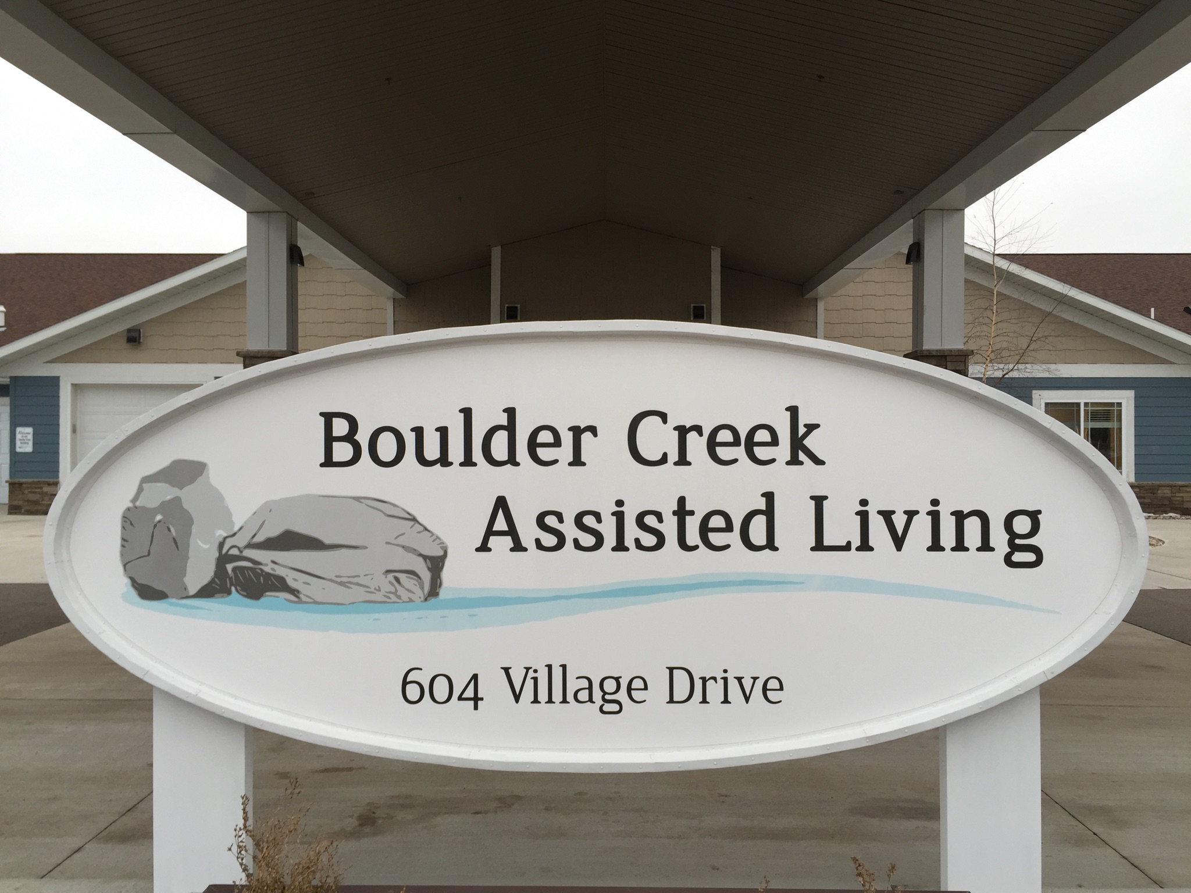  604 Village Drive  Marshall, MN. 56258  (507) 929-1234  Tammy@boulder-creek.org | Please Join me in congratulating, Israel Weyesa, HHA  Some of the best parts of my job besides being with our clients are to recognize and acknowledge staff that lives the vision of Boulder Creek to, ‘Enjoy today’s moments of joy’. Beginning this month we will recognize an employee who shares in a way that brings comfort and love to those we care for. Anyone can nominate someone as employee of the month. I have nomination forms and you can submit it and put it in the rent box, both are outside my office door. We had several nominations and it was difficult to choose just one person. (A nice problem to have!)  June 2017 Boulder Creek Employee of the month!  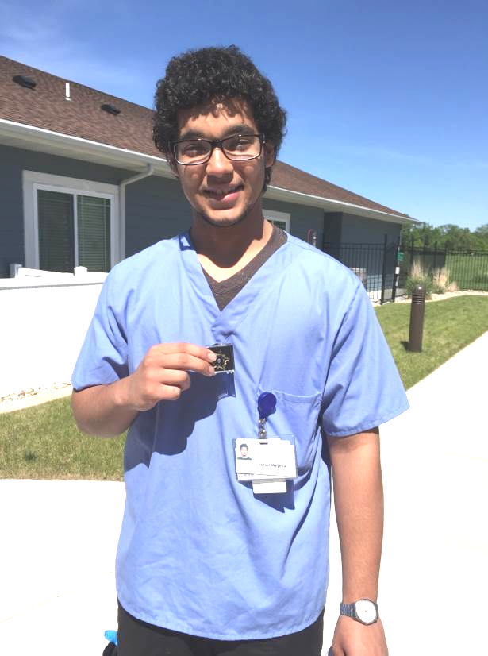  Israel sets a professional example of the type of caregiver we have at Boulder Creek. Israel was nominated by several coworkers as being respectful, kind and caring to the clients and always willing to help out a fellow coworker. Comments from family members and tenants affirm Israel is one of our best caregivers.  His mentor, Joshua stated being very proud of Israel's accomplishments at Boulder Creek. Israel is graduating from Marshall High this month. He will be attending SMSU in the fall.  Israel's award as employee of the month included: a commemorative pin 'Employee of the month-June", $50 in Marshall bucks, his picture will be in a special frame in both neighborhoods at BC and an article will appear in the Marshall Independent recognizing him for this award.  June brings many fun activities coming up for families to join in on. Check out the June calendar. We will be having our annual garage sale on June 21st, Wednesday from 9-6p.m. All proceeds will go to Alzheimer’s Association and the ‘Walk to End Alzheimer’s’.  We’ve welcomed two new tenants to Boulder Creek in May, and we have several of our college students now home for the summer working again. As we are all gearing up for the busy-ness of summer, I hope you will be able to join us for our monthly support group on June 20th at 5:30 and some of the fun activities we have planned this month. Hello summer! Tammy  

  June 2017    More on Diabetes from Melissa  Carbohydrates are an essential nutrient in our body. When they break down, they form glucose providing the body with energy for our organs and muscles and fuel for our brain. However, not all carbohydrates are the same. We want to eat carbohydrates with a low Glycemic Index. The Glycemic Index (GI) is a relative ranking of carbohydrate in foods according to how they affect blood glucose levels. Carbohydrates with a low GI value (55 or less) are more slowly digested, absorbed and metabolized and cause a lower and slower rise in blood glucose. This is a good thing because it doesn’t create a large rise or fall in blood sugar levels but rather a stable level and improves the body’s sensitivity to insulin. See chart on the side. Thank you, Melissa  Walk To End Alzheimer’s  Boulder Creek is excited to announce we are doing the Walk To End Alzheimer’s again this year! Last year was a huge success and we won a few different awards recognizing our team. I want to thank all those who supported us last year. We truly made a difference! For those of you who do not know, the Walk To End Alzheimer’s is a fundraising event for the Alzheimer’s Association. The Alzheimer’s Association is a non-profit organization that uses the money to fund care, support, research, awareness and advocacy. This year’s walk will take place on September 30th, 2017 in Willmar, MN. If you would like to donate money, join our team in helping fundraise, and/or join our team to walk with us, please click on the link below. Thank you in advance for your support! Together we will End ALZ! Melissa |   
June 2017    . UpDates from Jane/Activities   May was a very busy month filled with many fun times as we jump right into summer! Our entertainment, music with Dana & LuAnn, Sing-A-Long with Beth, Take Note Barbershop, music with Bruce, Guy & Guitar, and Marilyn. Our BIG event of the Month was our Mother’s Day Tea! We had two tea parties this year because of our many new tenants! The tables were decorated with fancy table cloths, napkins, tea cups, saucers and beautiful center pieces! Each mother, grandmother and great-grandmother received a hat pin corsage also.  June is here, and we have been having fun going outside and enjoying the nice weather on our back patio. We have been busy planting beautiful flowers and many vegetables. We have some very serious gardeners keeping an eye on the gardens! We are having a Father’s Day Picnic outside on the back patio on June 16th. Families are welcome. Please RSVP by June 9th by contacting the Activities Office. June 21st is our Boulder Creek Garage Sale from 9am-6pm for the Longest Day Fundraiser for The Walk Against Alzheimer’s. We are starting to accept donations for the sale up to June 21st….please bring larger items the day of the sale. Just in case you notice the staff wearing | Entertainment  June 1- Music w/Dana & LuAnn  At 1:15 pm  June 2- Sing A Long w/Beth  At 4:00 pm  June 21-Cletus Goblish  At 3:30 pm  June 23-Guy and Guitar  At 3:30 pm  wearing jeans on Fridays, we are having Casual Fridays--the staff pays $2.00 each week to wear jeans as a Fundraiser for the Alzheimer’s Walk on September 30th this Fall in Willmar. Remember to watch our Facebook page, Boulder Creek, Marshall, MN, for fun photos and videos through the month. Feel free to join in and attend any of our monthly activities! The next Family Support Group is scheduled for June 20th at 5:30pm, in the Boulder Creek Community Room. Hope to see you there! Enjoy your summer!  Jane
  Welcome To Our Team!  June 2017  Amber HHA Michelle HHA    Corina HHA Sandy Dining Srv    Bailee LEC Asst. Shonda LPN    Trista HHA Max HHA   | Welcome tenants!  Lowell Jeff    Church Schedule  Rosary is every Thursday at 10 am Chapel  June 13-Hymns w/Past. Johnston at  2:00pm  June 14-Catholic Mass at 10:45am  June 15-Church w/Past. Julie at 2:00pm  

