Creek Times 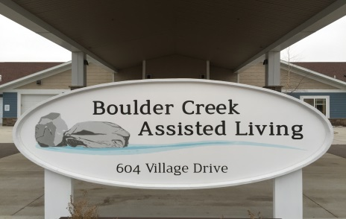
tammy@boulder-creek.org
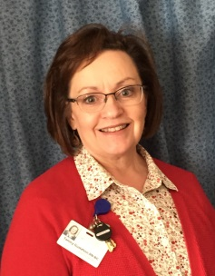
604 Village Drive Marshall MN. 56258 (507) 929-1234
Employee of The Month
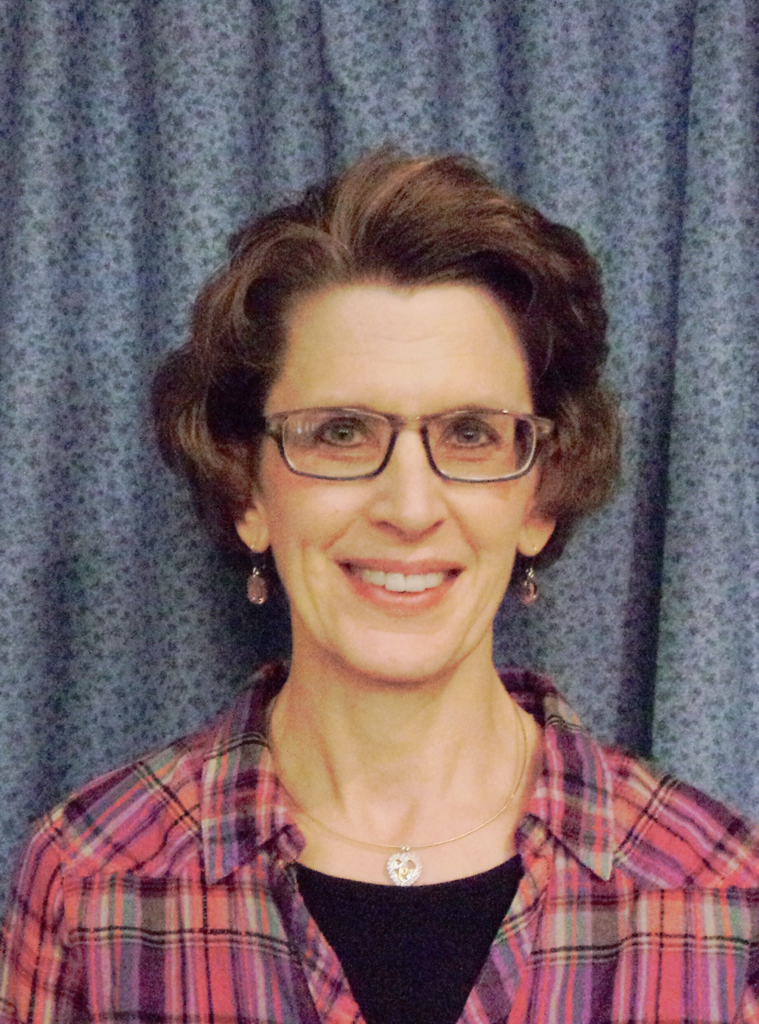
Congratulations to Jane Nelson-Como, Life Enrichment Coordinator-Activity Department. Jane was nominated by coworkers and family as always having a smile for the tenants. She enjoys being and doing things with them. She has a definite passion to help our tenants live life to the fullest. She does a great job communicating to families the tenants ‘moments of joy’. Please congratulate, Jane Nelson-Como as Boulder Creeks November Employee of the Month!
Thank you Jane for all you do for our tenants, your team work and making it fun for everyone!

This month’s newsletter contains a variety of topics. I have included a follow-up report regarding our door alarms and secure doors; things we learned from our first Department of Health survey and all the work in the Boulder Creek version of ‘Santa’s factory’ as tenants and staff get ready for the 2nd annual Fall Bazaar on November 17th and 18th. !
My challenge to our activity staff, Jane and Jessie, was to ‘create’ from recycled items. Jane had her deck and steps redone at her home this fall. She graciously donated the scraps and the tenants are making all sorts of nice holiday decorations. I think you will be impressed! The Fall Bazaar will have a nice variety of items made by the tenants and some items donated/made by staff and families. Most items will be priced and some will be on ‘silent auction’ bidding.
A few updates to the nursing side, some rules of our home care licensure have changed in regard to when services are added or subtracted from the client’s service plan. It used to be, the service plan needed a new signature when the added/subtracted services made for a change in cost. Now, we are required to have a signature for every change whether it changed the cost or not. This signature needs to be done within two weeks of the change. For clients with families that live a distance away this puts an added burden. We can accept an email confirmation as a signature. So if you haven’t given us an email address by which we can communicate this, and you are unable to stop by in that two week window, we will mail it to you with a return envelope. We are to stamp date when we receive it, as it is time sensitive. We will give you a phone call or email to tell you of the changes and why. We are allowed (by our license) to put the changes into effect as soon as needed, meaning we don’t have to wait for the signature. Some things, for example, like extra staff checks after a fall would be for monitoring the safety of the client. To wait until a hard copy signature is obtained, may jeopardize the client’s safety.
Please call either myself or one of the case managers if you have further questions on these changes.
Happy fall…stay warm! Tammy
FOLLOW UP REPORT
October 23-27 Boulder Creek and Boulder Estates had our first Department of Health survey. We are thankful there are folks who do this, as it helps us to do our jobs better and give better care to our clients. There are three items I want to pass onto everyone, one is the importance of reporting when you see a ‘vulnerable adult’ incident. All staff goes through an annual online training, going forward we will be adding a face-to-face training for all departments to educate on the Vulnerable Adult Act (VAA).
Briefly, the VAA states:
- If someone witnesses or suspects that a vulnerable adult (like all those who live at Boulder Creek and Boulder Estates) are being abused, neglected, maltreated or financially exploited, the general public needs to call 844-880-1574.
- Your name will be anonymous. The Department of Human Services will do the investigation.
- When a vulnerable adult is reported that lives in our facilities, and you report it to one of the staff, all the staff are mandated reporters and we are required to start an investigation and report it to the Minnesota Adult Abuse Reporting Center (MAARC).
- I have copies of the Vulnerable Adult Act in the lobby meeting room, feel free to help yourself.
We all want to protect our tenants. We appreciate the creative ideas that have been suggested by staff, family and surveyors. You will see some changes in primarily our morning and evening routines as we work to find more individual activities to keep the tenants occupied. It has been nice to see family come and do projects with their loved ones. If you would like to do something like this with your family member, let us know and we will see what we can do to make that happen.
The second item the surveyors stated is that we can’t lock tenant doors when they are inside the room. Sometimes this is a request of the tenant to keep wanders out. Even though the tenant can get out and the door does not lock on the inside, it is still a safety concern. The nurse needs to do a door lock assessment.
- The scenario the surveyors posed: ‘in the event of an emergency and staff didn’t have their keys, they wouldn’t be able to get into the room to assist the tenant to safety. The tenant must be able to hear a knock at the door while they are in bed and get out of bed by themselves and open the door.’ Most of Boulder Creek tenants could not do this safely.
- The room door can be locked when the tenant is not in the room if they wish.
- If you are a guest staying in the tenant’s room please inform staff if you would like the door locked for your privacy, as you would be responsible in the event an emergency exit is needed.
Thirdly, bed rails. We have some tenants that have bed rails. They now have to meet FDA guidelines as they are a safety risk. I have that information I will put in the lobby meeting room, help yourself.
A follow up on the mechanical door locks: We have set the door alarm on both neighborhoods to alarm as soon as one is through the door. The door will lock and alarm 8 seconds from the time you put swipe your key card/fob. If you need to hold it open for transporting people or items, you will have to have someone stop the alarm by putting your key card or fob in front of the black key box to shut it off. Regarding the door that leaves the central hallway into the lobby, no changes as of yet, but I am working on it.
Privacy of our clients is very important. All staff receives training on protecting the health information privacy of our clients. Some clients, families and staff have requested that no pictures be taken or posted to social media. We do our best to protect their wishes. When visitors come, we will try to pass it onto them, that although their intention is well meaning, we want to respect the tenant/family wish to not be photographed.
Thank you for being a part of the Boulder Creek Family! Happy November! Tammy
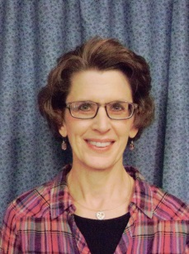
November is here and we are moving closer to the end of 2017!!! These next few months will be very busy with all the holiday festivities! This month we started out November with Music by Dana & LuAnn and Sing-A-Long with Beth—Western Dance Music! Special events this month will be Friday, November 10th, Some tenants will be going to the YMCA Outing for 2 hours in the morning. We are having a Veterans Day Program at 3:30pm and Guy & Guitar at 4:00pm. Our Boulder Creek Bazaar will be on Friday, November 17th, (10am-4pm) and Saturday, November 18th (10am-2pm) stop by and see what everyone has been busy with. Thanksgiving Day is on Thursday, November 23rd--so if you are going to have Thanksgiving Dinner with your family here (North 11:30am and South 12:00pm) please call and make reservation with the Activities Office by Monday, November 20th. Moving right on to the Christmas Season, on Wednesday, November 29th we have the Slew Foot Family Band coming at 3:30pm. They will be performing their “Christmas Show”!!! Please feel free to come to any of the activities this month and spend time with your family or friend who lives here at Boulder Creek!
Happy Holidays! Jane!!!

November Entertainment
November 2nd Dana and LuAnn @ 1:15pm on the North Side
November 3rd-Country Western Dance/ Music with Beth @ 3:45

November 10th-Celebration of Veterans Day will be @ 3:30pm on the South Side

November 10th-4:00pm
Guy and Guitar

November 29th-The Slew Foot Family/Christmas Show @ 3:30pm

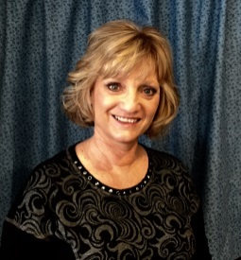 A True Story From A Caregiver
I eventually learned that there is an actual theory about this approach to reasoning with patients who have Alzheimer's and other dementias called "validation therapy." It makes me smile. I didn't need a theory to know what Dad needed. I just needed love.
Validation is exactly what Dad required, because his delusions were real to him. Yes, there were times when I would try to explain "true" reality, but I chose my battles wisely. I tried to keep him from seeing television news because he would insist that the war going on (there's always a war going on somewhere) was transpiring in our town, right outside his window. I would try to get him to walk to the window with me, but no, he knew the war was outside and I shouldn't belittle him by saying it wasn't.
However, I certainly did not encourage him and say, "Sure, Dad, there's a war outside and they will blow us up anytime." I would merely play along and try to convince him that we were in a "safe zone," so to speak. If it did not take, I would calmly say, "I'm sorry you can't believe me, but we are okay. We'll talk about it another time." Usually, these things happened when he was having a particularly bad day, and we would just have to ride it out.
If a particular delusion did not cause him to feel threatened or upset, I resorted to just agreeing with him. What did it hurt that he thought he was helping plan the new zoo in Fargo, including finding an elephant for one of their exhibits? It kept him busy and helped him feel useful. What did matter that he needed to study "Grey's Anatomy?" I found him a copy in the used book store and brought it to him. He also requested a copy of "Robert's Rules of Order." These things were easy enough to find and readily available for purchase.
My point is this. Dad's reality was as real to him as mine is to me. Why should I, a person who supposedly can use their brain, make his life miserable by continually telling him he is wrong? Going with the flow was not hurting anyone else, and it was making Dad's life a little more bearable.
It is certainly a personal choice to make if you are the family caregiver for a loved one who is suffering from dementia. It seems to be a simple solution to allow them to persist in their reality, as long as it is safe and does not pose any harm to themselves or others. Perhaps it is no different than allowing a child to dream of what they want to be when they grow up or pretend that they are firefighting hero or a prima ballerina. There is no cure for dementia and it is a progressive, debilitating disease. There certainly seems to be no harm in validating their reality now and then throughout their final years. The other alternative often includes conflict, tension and hurt feelings. Why would I not do what little I could to help my father feel some sort of purpose, peace and accomplishment? I am his daughter. He would have done as much for me.
Over the span of two decades, author, columnist, consultant and speaker Carol Bradley Bursack cared for a neighbor and six elderly family members. Her experiences inspired her to pen, "Minding Our Elders: Caregivers Share Their Personal Stories," a portable support group book for caregivers.

Happy Birthday!
Lon
And
Lawrence

From your Boulder Creek family!

Reminder
Our Fall Bazaar will be on Fri. Nov. 17th 10-4pm and Sat. Nov. 18th 10-2pm
Church Schedule
November 2nd 10:00am-Rosary
November 8th 10:45am-Catholic Mass in the South Chapel
November 9th 10:00am-Rosary
November 16th 10:00-Rosary
November 21st 2:00pm-Hymns with Pastor Johnston
(There will be no Rosary on November 23rd
November 30th 10:00am-Rosary
November 30th 2:00pm-Church w/Pastor Julie

Rosary is held in the South Chapel
Every Thursday unless noted.
Thank you to Rick and Ivy for leading Rosary every week! We appreciate you very much!

